Directorate of Public Health & Wellbeing  Ground Floor, 3-5 St James Road, Dudley DY1 1HZ  www.dudley.gov.uk |  |  |  | 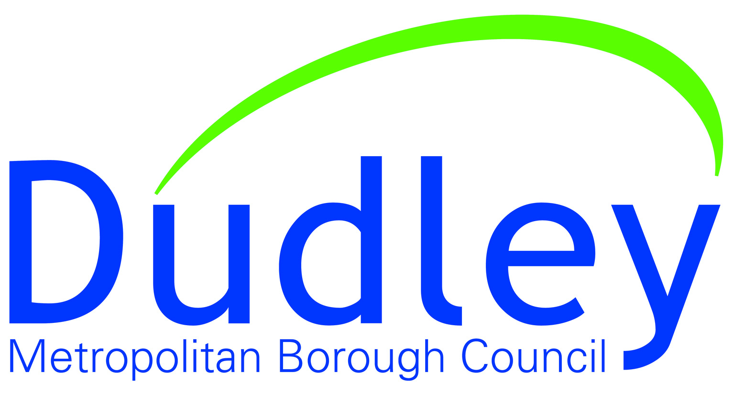

Dear Parent/Carer
You may be aware there has been a confirmed case of Coronavirus (COVID-19) in Dudley.
However, risk remains low to the public and the NHS is well prepared for these types of incidents.
The best way to protect yourself and your child from Coronavirus is to follow the Catch it, Bin it, Kill it advice and to wash hands with soap & water for at least 20 seconds. More frequent hand washing is advised particularly before touching your mouth, eyes or before eating food.
Based on current evidence, Coronavirus (COVID-19) presents with flu-like symptoms including a fever, a cough, or difficulty breathing. The current evidence is that most cases appear to be mild. Anyone who is concerned about health symptoms is advised to follow the advice about what to do on the Government’s website at https://www.gov.uk/guidance/wuhan-novel-coronavirus-information-for-the-public and nhs.uk at https://www.nhs.uk/conditions/coronavirus-covid-19/
FAQs
How serious is the coronavirus?
- The infection is mild for most people, including children. Older people, and people with pre-existing medical conditions (such as asthma, diabetes, and heart disease) may be at higher risk of more serious illness.

- Most people get better with enough rest, and plenty to eat and drink.

How likely are you to catch the virus?
- The chance of being in contact with the virus is currently low in the UK.

- You can only catch it if; you have been close to a person who has the virus (less than 2 metres for more than 15 minutes) or by touching a contaminated surface, then touching your mouth or eyes without washing your hands first.

Recent travel
If you and/or your child has returned from;
- Iran
- Hubei province in China
- Specific areas in Italy
- Specific areas in South Korea
For country specific areas see https://www.gov.uk/guidance/wuhan-novel-coronavirus-information-for-the-public. You should self-isolate at home and call 111 even if you do not have symptoms.
- If you or your family have been to any of the following countries or regions highlighted here https://www.gov.uk/guidance/wuhan-novel-coronavirus-information-for-the-public and have developed symptoms, self-isolate at home and contact NHS 111 for advice.

- If you haven’t been close to anyone with confirmed COVID-19 or haven’t been to any of the places above or in the link, you are fine to carry on as normal.

What you and your children can do to stop the spread of coronavirus

- Covering your nose and mouth when coughing or sneezing, using a tissue when possible.
- Disposing of dirty tissues promptly and carefully.
- Cleaning hard surfaces (such as door handles) frequently using a normal cleaning product.
- Most important of all is washing your hands frequently with soap and water.

If you need any further information visit https://www.nhs.uk/conditions/coronavirus-covid-19/

Information is also available on the council website www.dudley.gov.uk/coronavirus

Yours sincerely
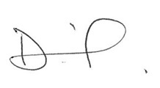

Deborah Harkins
Director of Public Health & Wellbeing

Produced by Dudley Health Protection Team 09.03.2020


