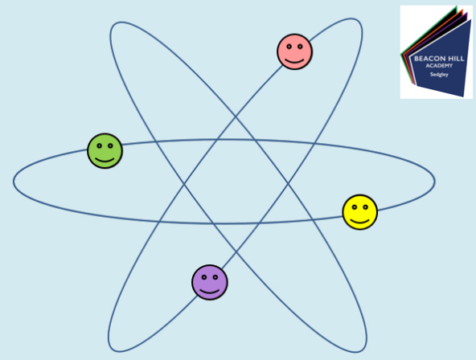
Beacon Hill Academy
Teach Yourself Science!!

Date:________________________
Lesson Number:________________
Title:________________________________

DNA Task:

Write the keywords about the Planets and other objects that makes up our Solar System

Design a mnemonic to help you remember the order of the planets

Pick your 3 planets:

Write an analysis of the graph:

SATS question:

Homework Task:

Remember to print this sheet or save into an appropriate folder.

