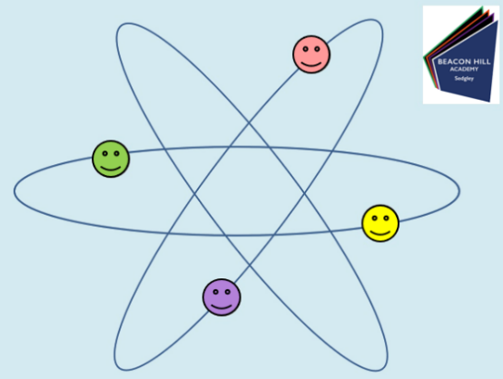
Teach Yourself Science!!

Date:________________________
Lesson Number:________________
Title:________________________________

DNA Task questions (5 mins)

Animal cell and labels

match the function to the cell component
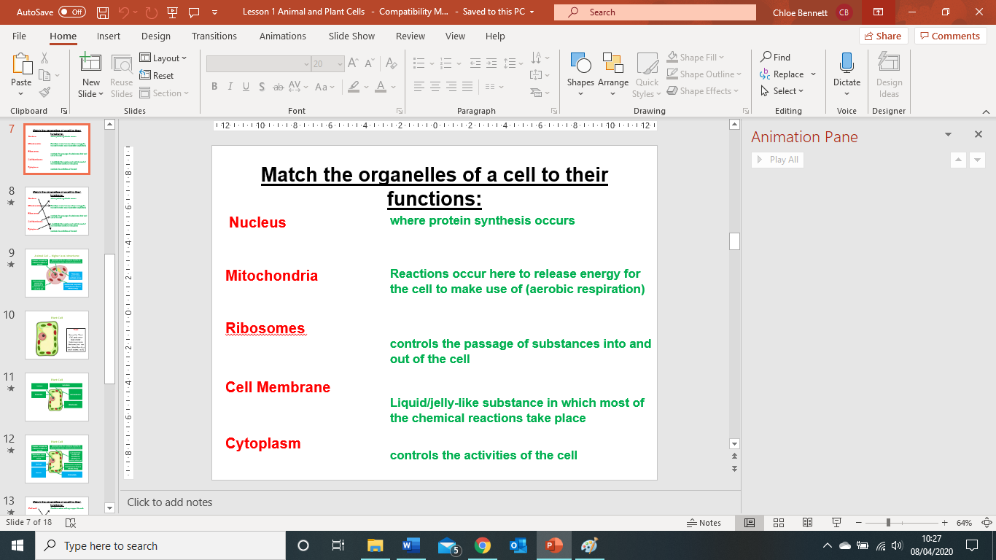

Animal cell and labels

match the function to the cell component
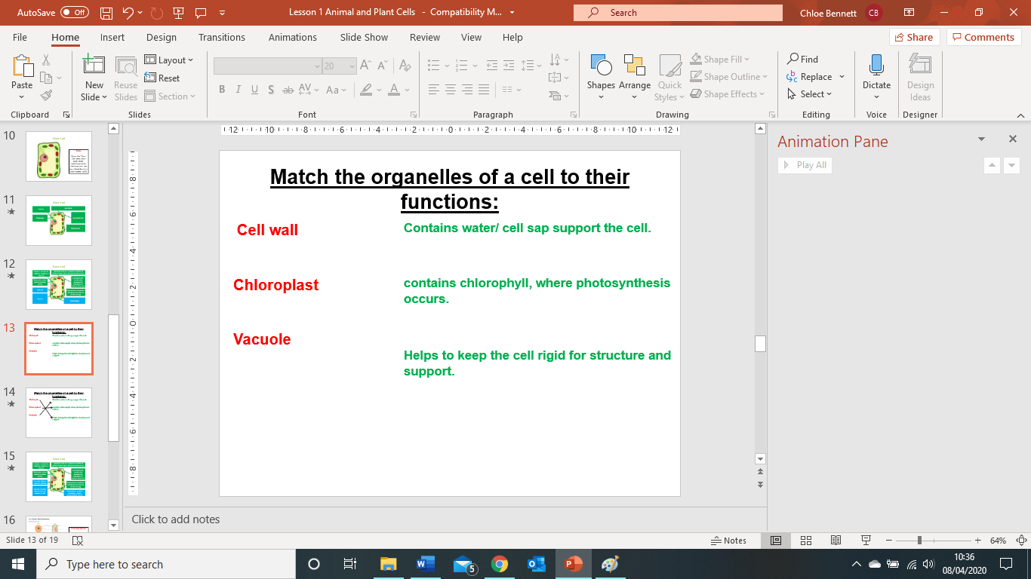

True OR False

Bingo – Choose 3 of the keywords

Remember to print this sheet or save into an appropriate folder for your own records.

