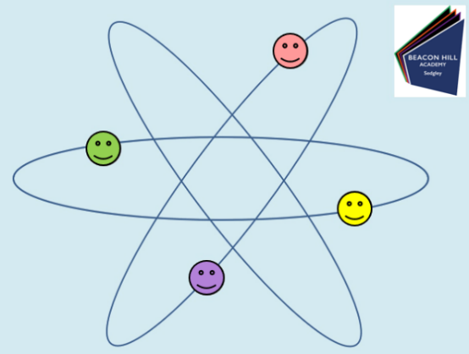
Teach Yourself Science!!

Date:________________________
Lesson Number:________________
Title:________________________________

DNA Task questions (5 mins)

What cells can you see, describe them?

Match the cells to the descriptions
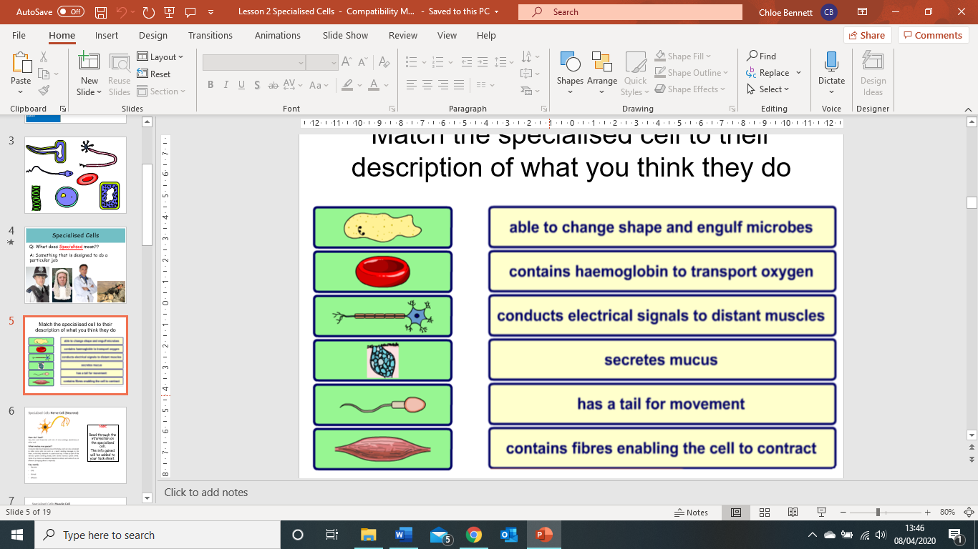

What cells can you see, describe them?

Specialised Cell Name | Diagram | Description of key features | Function

Progress Check
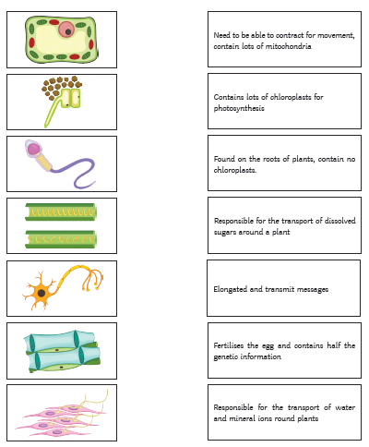

What am I?

Remember to print this sheet or save into an appropriate folder for your own records.

